Social Issues and Competitive Sport – Drug Use

David Dymond, an Lukas Holland
Slippery Rock University
American Sport in the 21st Century

February 25, 2016
TABLE OF CONTENTS

- INTRODUCTION……………………………………………………………………….3

- WHAT KIND OF DRUGS ENHANCE SPORT PERFORMANCE?.....….…………3
  - Anabolic Steroids………………………………….……………………….…...…4
  - Human Growth Hormones………………...………………………………………5
  - Stimulants…………………………………………………………………………6
  - Blood and Gene Doping……………………………….……………….…………9

- RECORDS AND STERIOD USE. SHOULD RECORDS STAND IF ATHLETES ARE FOUND GUILTY OF TAKING DRUGS?..........................................................10

- WHAT HAVE THE MLB, THE NFL AND OTHER MAJOR LEAGUES DONE TO CURB DRUG USE IN SPORTS AND WHAT MORE COULD/SHOULD BE DONE?..............................................................................................................................11

- CONCLUSION…………………………………………………...…………….………13

- REFERENCES………………………………………………………………………….15

- APPENDIXES………………………………………………………………………….18
  - Appendix A: Reason and Side Effects of Anabolic Steroids………………….…18
  - Appendix B: Guide to Performance-Enhancing Substances…………………….20
  - Appendix C: Effects of Caffeine Supplementation ………………….………….22
  - Appendix D: Gene Variants in Gene Doping……………………………………24

INTRODUCTION
In sport, there have always been different versions of cheating. Ty Cobb for example in the early 1900’s sharpened his cleats, so when he slid into bases he would cut up the opposing player. More recent examples of cheating are Barry Bonds and Lance Armstrong who used performance enhancing drugs to gain a competitive edge and win. Players use a various number of methods to enhance performance.
Two main techniques of performance enhancing methods are used heavily in sport today are blood doping in endurance sports like cycling and track, and anabolic steroids or growth hormones in strength based sports like football and baseball., There are an abundance of different substances that enhance sport performance (see Appendix B for table on list of performance-enhancing substances). These includes stimulants like amphetamines, cocaine, and gene doping (Momaya 2015). These substances can enhance physical strength, energy, speed, endurance, and other key abilities needed to exceed in sport.
Another question is raised when one is talking about performance enhancing drugs. If a player is caught doping, should their records stand. Athletes have been caught doping or have openly admitted to using performance enhancing drugs. Some examples are big name athletes that once were the top names in their respected sport, Barry Bonds, Lance Armstrong and Ben Lewis. These players were caught doping by their governing sport bodies.
Organizations and Professional sports have stepped into action. These organizations include the World Anti-Doping Agency (WADA), United Nations Educational, Scientific and Cultural Organization (UNESCO), National Football League (NFL), Major League Baseball (MLB), National Association for Stock Car Auto Racing (NASCAR) and National Collegiate Athletic Association (NCAA) (Cadwallader, 2015). Some are nationally based and others are based specifically in one country (NFL, MLB, NASCAR, NCAA). These organizations do random testing upon their athletes to prevent the use of performance enhancing drugs to ensure fair competition and a clean league for years to come.
WHAT KIND OF DRUGS ENHANCE SPORT PERFORMANCE?
Anabolic Steroids
Anabolic steroids are one of the drugs that enhance sport performance. They are a synthetic drug that acts as the male hormone, testosterone. These drugs help mostly with the increase in the growth of muscle. Anabolic steroids are primarily used for a few reasons: competitive sport, cosmetic, occupational and therapeutic (see Appendix A for table on Reasons) (Sari 2010). The purpose of using these drugs is to obtain a competitive edge by enhancing physical performance. Almost all leagues and organizations have banned these drugs. This has been done so by the World Anti-Doping Agency, who has it on the prohibited list (Maquirriain, 2012).
The main purpose of Anabolic steroids is to grow muscle and put it on faster than you normally would. Players also benefit from an increase in strength and lean body mass (Momaya 2015). Also, some athletes using these drugs often see an increase in speed. Athletes who participate in strength sports like baseball, weight lifting, rowing, football and wrestling are more likely to use these drugs (Sari, 2010). Baseball players take Anabolic steroids to hit harder and throw harder Weight lifters need to be able to lift heavy weights and have the right form and Anabolic steroids help with these activities. Rowers use AS to increase upper body strength dy. Football players do not use these drugs as much, but do so to add strength and speed. Wrestlers, usually more ultimate fighters, use it to build the perfect ratio of lean mass and muscle. (CITE)
Although there are some benefits to taking anabolic steroids, there are also negatives. To begin, steroids are banned by almost every organization and league worldwide. Another disadvantage is the affect they have on the athlete’s health (see Appendix A for table on health risks). These substances also effect mental health. These effects include anxiety, irritation and anger (Lindqvist 2013). The anger is usually related to, or called, roid rage and can lead to an athlete becoming more violent... Other side effects include: high blood pressure, reduced sexual activity, acne, nausea, dizziness, headache, urethritis, depression and muzziness (Sari 2010). Muzziness is to be mentally confused or puzzled.
Human Growth Hormone
Human growth hormones have received a lot of attention over the past five years. HGH are used by athletes (for what purpose). Medically they were developed to treat deficiencies that are genetically formed. The human growth hormone functions as it releases the somatotrophs (Momaya 2015). This substance can also be found on the WADA Prohibited List, which means it is banned by international organizations and the International Olympic Committee (WADA 2012).
The biggest benefit of this type of drug is that it helps improve overall athletic performance by increasing muscle mass (Momaya 2015). This means that athletes can work out and train harder and have more output from doing so. Extensive exercise will reduce the amount of fat mass while on human growth hormones and make the athlete stronger than they were before. This drug again is more common in strength based sports.
The effects human growth hormones have on the human body can be life threatening like any drug. By taking this substance, an athlete risks the chance of contracting cancer and cardiovascular disease (Momaya 2015). Both health risks can cause high concern for a former athlete. Cancer. Another major side effect of taking HGH is forming an insulin resistance. This means the body requires a high dosage each day to keep levels at equilibrium. Other minor affects include: fluid accumulation, arthralgia, carpal tunnel and pseudotumor Cerebri (Momaya 2015). Fluid accumulation is when the body produces more fluids than it can handle, often relating to problems with the kidneys. Arthralgia is joint pain, which a lot of older people have. Carpal Tunnel is a condition that occurs in the hand and is very painful. It usually occurs because of the compression of a major nerve (Ghiasse 2015). Usually feels odd sensations in these two areas, which are burning, numbness and tingling. Pseudotumor Cerebri is chronic headaches (Marton 2008).
Stimulants
A stimulant is a substance in the body that raises nervous activity or physiological levels. One of the most popular stimulants is amphetamines (Cooter 1981). These drugs are more commonly used to alter o mood, and are usually prescribed to patients with narcolepsy and children with Attention Deficit Hyperactivity Disorder (ADHD). The use of amphetamines has grown over the decades in sport to gain a competitive edge. Amphetamines are also called pep pills, greenies and uppers (Cooter 1981).
This drug is used for increased strength, muscular power, acceleration, speed, anaerobic and aerobic capacity while also helping with raised levels until exhaustion (Momaya 2015). Amphetamines often taken by baseball players due to the long games and the power they need throughout the game. Football is another sport that amphetamine use is common in due to the high speeds athletes run and the pace of play.
Amphetamines do have some adverse effects on the human body. These effects are usually related to the raising of CNS stimulation. The most common side effects include agitation, restlessness, nausea, gastrointestinal upset and rebound fatigue. Some serious side effects are seizures, hallucinations, heat exhaustion, arrhythmias and dependence (Momaya 2015). Arrhythmias is a condition relating to the heart causing irregular heartbeats or causes the heart to beat out of rhythm (Grossman 1993). Seizures cause convulsions and can cause brain damage. Hallucinations involve seeing something that is not really. Heat exhaustion causes the body to overheat like a car. This causes sweating and a raised pulse, and in extreme causes a panic attack or even death (Matsumoto 2014).
Another stimulant that is starting to be limited at the collegiate level is caffeine. The primary functions of this substance are inhibiting the release of excitatory neurotransmitters in the brain by adenosine suppressing physiological arousal and neuronal excitability (Trexler 2015). This process helps with alternating pain level and effort perception. Caffeine helps to raise energy levels, but the stimulant is not banned by WADA. The limit or policy for the NCAA is that an athlete’s caffeine levels must be lower than six cups of coffee (Momaya 2015).
. This particular one helps to delay fatigue, which is the biggest benefit, which is more common in improving cycling trials and decreases cross country time (Momaya 2015). For example, in a test 18 female soccer players were given a dosage of caffeine and this raised their mean counter movement jump (CMJ), height, and speed (see Appendix C for table on caffeine supplementation) (Trexler 2015).
The reason athletes take this substance is because there are few side effects. Any adverse effects related to caffeine are the need to hydrate during competition. Athletes will continue to take this substance due to it not being banned and not having any effects on the body that are known right now.
Blood and Gene Doping
Blood doping is the misuse of substances and certain techniques to maximize the delivery of oxygen to muscles, with the aim to optimize performance in sport performance (De Oliveira 2014). Blood doping includes blood transfusions, administration of blood substitutes, and gene manipulation. Blood transfusions, more specifically autologous, are the most common way to blood dope (Segura 2014). This process has been used for a long time and has become popular over the years in many different sports, including cycling, track, and baseball.
A natural way to improve the delivery of oxygen to the muscles is to train at high altitudes, but often athletes find it easier to just use doping methods. Blood doping helps with sport performance by enhancing stamina (De Oliveira 2014). One athlete who was caught blood doping is Lance Armstrong, a very talented cyclist who once had testicular cancer. While blood doping, Lance Armstrong’s fatigue levels went down and his stamina increased. Blood doping is used for more than just stamina. The process can also help with strength. This specific use is more common in baseball. Alex Rodriguez is one athlete who used this method to gain strength, but he had been caught before for steroid use
Some athletes underestimate the side effects of blood doping, but should not. Some side effects of these drugs include hypertension, headaches and increase risk for a thromboembolic event due to the raised levels of viscosity and hematocrit (Momaya 2015). Hypertension is a condition that relates to high blood pressure (Neilson 2016). This can lead to some other serious heart conditions that can be fatal. Headaches aren’t too serious unless they cause the individual to become physically ill due to the pain. However, a thromboembolic event is a very serious adverse effect of blood doping. It causes a clot in a blood vessel that can break off and be carried throughout the blood stream until it possibly clots another blood vessel (Leijtens 2014). Ultimately, if it is not caught in time it can lead to the heart which can be fatal.
Gene doping is the transfer of nucleic acid sequences or the use of normal or genetically modified cells to enhance sports performance (Van 2013). Gene doping is a concern in sports medicine. This technique is prohibited in competitive sport and no matter how an athlete uses it, it is considered doping. There is a long list of genes that can be genetically modified and used for blood doping. Each one’s purpose is somewhat different. Some of these genes consist of angiotensin-converting enzyme, nitric oxide synthase, muscle creatine kinase, matrix metallopeptidase, and brain-derived neurotrophic factor (Pokrywka 2013). Gene doping helps with four main performance categories. The categories are endurance ability, muscle performance and power exercise, susceptibility to injuries, and psychological aptitude (Pokrywka 2013). Some genes can fall under more than one category like the angiotensin-converting enzyme, which helps with endurance ability and muscle performance and power exercise (see Appendix D for table showing full list of genes). Many athletes benefit from gene doping due to the lack of testing that is available. Athletes who compete in sports like baseball or swimming can use this technique to improve performance. Baseball players can increase their throwing and hitting power while helping with stamina for those long extra-inning games. Swimmers can use gene doping to help with their endurance ability for a race like the 1500-meter freestyle. Some of the t known risks of gene doping are gene silencing, immune reaction, integration, infection of germs, expression, storage and usage and long term (Van 2013). Gene silencing is when the target area is infected and the inserted gene may not work (Katoch 2013). Depending on how the body reacts to the gene, it could cause an immune reaction. Gene doping can lead to cancer depending on what gene is used, this is caused by integration (Van 2013).; Gene doping can also cause infection with germ cells. Expression is hard to control with gene doping. Good storage is required while gene doping, one choices to abuse this while gene doping. Since gene doping is still a new method, long term effects cannot be calculated yet.
RECORDS AND STERIOD USE. SHOULD RECORDS STAND IF ATHLETES ARE FOUND GUILTY OF TAKING DRUGS?

Performance enhancing substances help athletes achieve great feats in their respective sports. Doping allows them to hit a baseball farther, run and cycle faster, and throw a ball with great speed. Doing these well over periods of time helps some athletes break records within their sport, such as: Lance Armstrong’s record seven Tour de France titles, Barry Bond’s career home run and single season home run records, Rodger Clemons’s record for most Cy Young Awards won in a career, and Ben Johnson’s world records in the 100-meter dash and the 60-meter dash (Underwood 1989).
Ben Johnson was an Olympic sprinter for Canada. He was originally from Jamaica and immigrated to Canada in 1979. Johnson finally received his official citizenship in 1980 (Jackson 2001). In 1987 Ben Johnson started receiving national attention after some early athletic victories. At the Seoul Olympics Ben Johnson beat Carl Lewis and set the world record for time in the 100-meter dash with 9.83 seconds and beat Lee McRae for the record in the 60-meter dash with 6.41 seconds in Indianapolis (Underwood 1989). After this, Ben Johnson became a hero and an international superstar.
Unfortunately, this fame did not last long. Although Johnson won the premier event at the Olympic games and was the first Canadian to win a medal since Percy Williams in 1932, he tested positive for steroids right after the event (Jackson 2001). At first Ben Johnson was in complete denial before confirmation came out. All of Canada reacted to this news and started saying Johnson was a disgrace to Canada.
The International Amateur Athletic Federation (IAAF) had a debate to revoke all records set by athletes who admitted using performance enhancing drugs (Underwood 1989). One athlete that was affected by this ruling was Ben Johnson. The IAAF stripped Ben Johnson of his two world records. Transferring them to both runner ups in these events, Carl Lewis in the 100-meter and Lee McRae in the 60-meter. Johnson was also later stripped of his gold medal by the International Olympic Committee (IOC) and passed on too Carl Lewis (Underwood 1989).
Ben Johnson was eventually banned for life by the IAAF for failing another drug test in 1993 (Jackson 2001). After being banned for life, Johnson continued to battle for his right to complete. Johnson was told by the Prime Minister that he should move back to Jamaica, his birthplace, because he was again a disgrace to Canada (Jackson 2001). Edward Futerman, who was Ben Johnson’s lawyer during the Dublin Inquiry, said that Canada was unfairly singled out through this ruling (Jackson 2001). Futerman also said that this will forever affect the fight against performance enhancing drugs. Ben Johnson’s lawyer also mentioned that this has put a muzzle on cleaning up this international problem because athletes will be afraid of the repercussions.

WHAT HAVE THE MLB, THE NFL AND OTHER MAJOR LEAGUES DONE TO CURB DRUG USE IN SPORTS AND WHAT MORE COULD/SHOULD BE DONE?

The major leagues such as the MLB, the NFL, the NHL as well as the international sport community realized that doping in sport was a problem that needed to be addressed. This led to the formation of the World Anti- Doping Agency (WADA) in 1999 (Dimeo 2013) which is a governing body against doping in sports internationally. This agency sets the rules and regulations for all sports and all athletes performing in those sports in order to clear up confusion and streamline the testing and research of performance enhancing substances. Another factor of eradicating player enhancing substance use internationally is for countries to ratify the United Nations Educational, Scientific and Cultural Organization (UNESCO) International Convention against Doping in Sport so that new measures can be put in place. Another method of preventing further player enhancing substance use in sport is educating especially children but all people not to use these substances (Pound 2007). WADA rules that the athletes are responsible for the illegal substances found in their bodies when tested (Cadwallader 2015). MLB players like Barry Bonds and Alex Rodriguez have argued that they only tested positive for steroid use because a trainer or a family member gave them steroids without them knowing. It has been made illegal whether or not the athlete knows to prevent that from being a way out for those who have failed drug tests.
Professional athletes are usually considered employees of their team or of the league so they unionize to be able to negotiate through the collective bargaining process. One of the mandatory subjects of collective bargaining for MLB and the MLB Players Association (MLBPA) as well as the NFL and NFL Players Association is steroid use. Both sides have to agree on a testing process because a league cannot put a drug testing policy without the consent of the Players Association. MLB was forced to put a policy like that in place after a Congressional report, the Mitchell Report, found that many current and former MLB players were using performance enhancing drugs (Hanson 2015).
Both sides also negotiate the punishments for people who test positive. Each league has its own punishments for violations. These punishments vary in harshness from warnings to suspensions and banishment from the league. For MLB, a first offense is a fifty-game suspension, a second offense is a 100-game suspension, and a third offense is a permanent suspension from Major League Baseball and Minor League Baseball. The league recently banned their first player after he tested positive for steroids a third time. NFL players are tested randomly throughout the year and can be suspended for positive tests. The NBA is much more worried about its players using street drugs like cocaine, PCP, and marijuana and punishes players that do much more harshly than those that test positive for performance enhancing substances. If a player is banned for steroid use or marijuana, they can reapply to join the league. The NHL started drug testing in 2005. Each player is randomly tested two times or less a year, with at least one of the tests done with the entire team. The first positive test result resulted in a twenty-game suspension without pay, the second failed test is a sixty-game suspension, and after a third positive test, the player is suspended permanently (Hanson 2015).
CONCLUSION
Drug use in competitive sport is a very diverse problem. With technology advancing so rapidly there are numerous new ways to dope, like gene doping. Athletes will always continue to use performance enhancing substances. Players will always go that extra mile to gain a competitive edge, even if it means taking anabolic steroids, human growth hormones, stimulants, and blood doping, along with the newer method, gene doping. These athletes using these drugs only know the benefits of these performance enhancing substances. They are not often aware of the adverse effects it has on the body. These people who are willing to cheat only care about the paycheck that comes with their performance if they do not get caught, like many do.
Many believe athletes who do use performance enhancing substances should be looked at as cheaters and be stripped of their titles and records. Lance Armstrong already paid for his choices by being stripped of his Tour de France titles from his career in cycling. Barry Bonds is another player whose home run record is under debate due to him using performance enhancing drugs. Many think Hank Aaron should rightfully hold that record. In current events, Jenrry Mejia was kicked out of the MLB permanently. This player got caught three times in one year and is in clear violation of MLB rules.
The Mejia case is just one example of how professional leagues are trying to control the use of performance enhancing drugs. The MLB, NFL, NBA and NCAA have protocols and procedures to test these athletes randomly to make sure this problem is being limited. National organizations are to help with this movement. If it wasn’t for WADA there would be no standard for this issue. WADA is the organization that bans most performance enhancing drugs and updates this list periodically. Another organization that is based nationally is the International Olympic Committee, which usually follows WADA. This shows that organizations nationally and internationally are coming together to put an end to doping in all sports.

REFERENCES
Cadwallader, A. B., & Murray, B. (2015). Performance-enhancing drugs I: Understanding the basics of testing for banned substances. International Journal of Sport Nutrition & Exercise Metabolism, 25(4), 396-404.
Cooter, G.R. Amphetamines and sports performance. (1981). Journal of Sport Psychology, 3(1), 14.
de Oliveira, C. R., de Bairros, A. V., & Yonamine, M. (2014). Blood doping: Risks to athletes' health and strategies for detection. Substance Use & Misuse, 49(9), 1168-1181.
Dimeo, P. (2014). Why lance armstrong? Historical context and key turning points in the ‘cleaning up’ of professional cycling. International Journal of The History of Sport, 31(8), 951-968.
Dimeo, P., & Taylor, J. (2013). Monitoring drug use in sport: The contrast between official statistics and other evidence. Drugs: Education, Prevention & Policy, 20(1), 40-47.
Ghiasse, S., & Harriss, A. (2015). Keys to a return-to-work process. Occupational Health, 67(12), 27-30.
Gleaves, J. (2014). A global history of doping in sport: drugs, nationalism and politics. The International Journal of the History of Sport, 31(8), 815-819.
Grossman, P., & Kollai, M. (1993). Respiratory sinus arrhythmia, cardiac vagal tone, and respiration: Within- and between-individual relations. Psychophysiology, 30(5), 486-495.
Hanson, G. R., Venturelli, P. J., & Fleckenstein, A. E. (2015). Drug testing in sports. Drugs and Society (12th ed., pp. 677-696).
Jackson, S. J., & Ponic, P. (2001). Pride and prejudice: Reflecting on sports heroes, national identity, and crisis in Canada. Culture, Sport, Society, 4(2), 43.
Jedlicka, S., & Hunt, T. (2013). The international anti-doping movement and UNESCO: A historical case study. International Journal of the History of Sport, 30(13), 1523- 1535.
Katoch, R., & Thakur, N. (2013). RNA interference: A promising technique for the improvement of traditional crops. International Journal of Food Sciences & Nutrition, 64(2), 248-259.
Kirkwood, K. (2009). Considering harm reduction as the future of doping control policy in international sport. Quest (00336297), 61(2), 180-190
Leijtens, B., Kremers van de Hei, K., Jansen, J., & Koëter, S. (2014). High complication rate after total knee and hip replacement due to perioperative bridging of anticoagulant therapy based on the 2012 ACCP guideline. Archives of Orthopedic & Trauma Surgery, 134(9), 1335-1341.
Lindqvist, A. S., Moberg, T., Eriksson, B. O., Ehrnborg, C., Rosén, T., & Fahlke, C. (2013). A retrospective 30-year follow-up study of former Swedish-elite male athletes in power sports with a past anabolic androgenic steroids use: a focus on mental health. British Journal of Sports Medicine, 47(15), 965-969.
Maquirriain, J. (2012). 2012 WADA prohibited list summary of major modifications and explanatory notes. Medicine & Science in Tennis, 17(1), 40-41.
Marton, E., Feletti, A., Mazzucco, G. M., & Longatti, P. (2008). Pseudotumor cerebri in pediatric age: role of obesity in the management of neurological impairments. Nutritional Neuroscience, 11(1), 25-31.
Matsumoto, T. (2014). Heat illness and body temperature regulation in men. Advances in Exercise & Sports Physiology, 20(4), 77.
Momaya, A., Fawal, M., & Estes, R. (2015). Performance-enhancing substances in sports: A review of the literature. Sports Medicine, 45(4), 517-531.
Nielson, C. M., Lockhart, B. D., Hager, R. L., George, J. D., Eggett, D. L., Steffen, P. R., & Bailey, B. W. (2016). The effect of cardiowaves interval training on resting blood pressure, resting heart rate, and mind-body wellness. International Journal of Exercise Science, 9(1), 89-100.
Pokrywka, A., Kaliszewski, P., Majorczyk, E., & Zembroń-Łacny, A. (2013). genes in sport and doping. Biology of Sport, 30(3), 155-161.
Sari, İ. (2010). anabolic androgenic steroids and dependence. Journal Of Physical Education & Sport / Citius Altius Fortius, 28(4), 68-74.
Sefiha, O. (2010). Now's when we throw him under the bus: Institutional and occupational identities and the coverage of doping in sport. Sociology of Sport Journal, 27(2), 200- 218.
Segura, J., & Lundby, C. (2014). Blood doping: potential of blood and urine sampling to detect autologous transfusion. British Journal of Sports Medicine, 48(10), 1-6.
Underwood, N. (1989). Starting over ben johnson will lose two world records. Maclean's, 102(38), 66-67.
van der Gronde, T., de Hon, O., Haisma, H. J., & Pieters, T. (2013). Gene doping: an overview and current implications for athletes. British Journal of Sports Medicine, 47(11), 1-11.

Appendix A
Reason and Side Effects of Anabolic Steroids

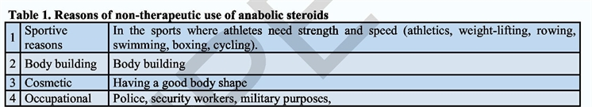



Appendix B
Guide to Performance-Enhancing Substances

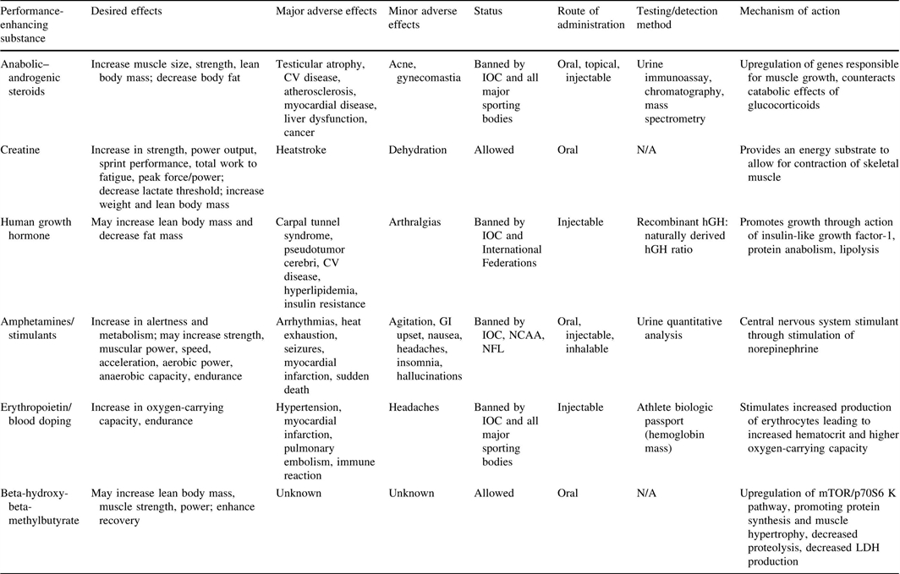

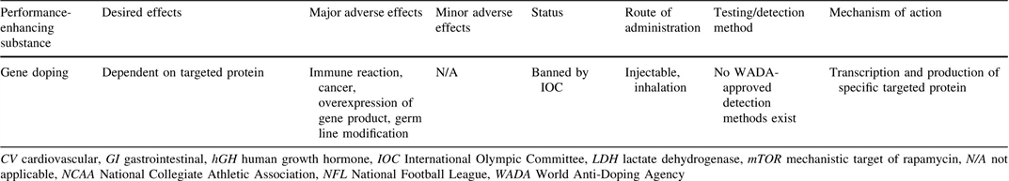

Appendix C
Effects of Caffeine Supplementation on Strength and Sprint Performance

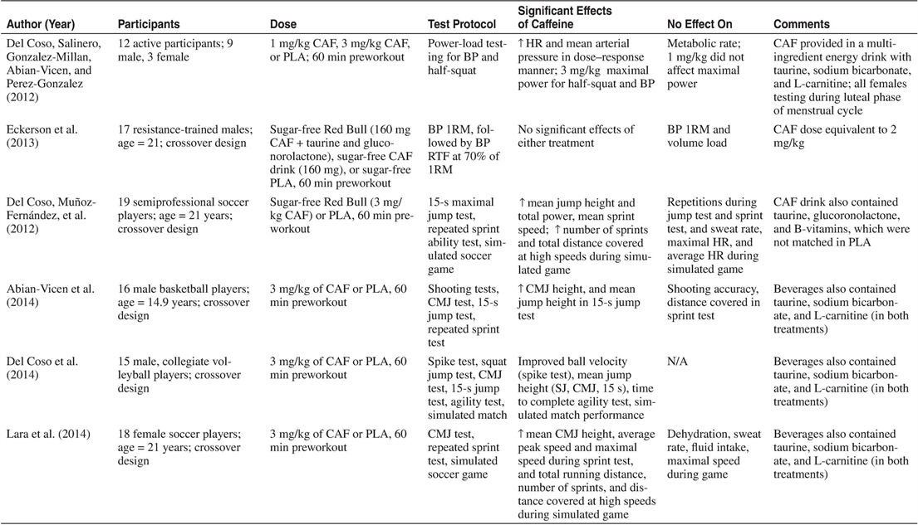

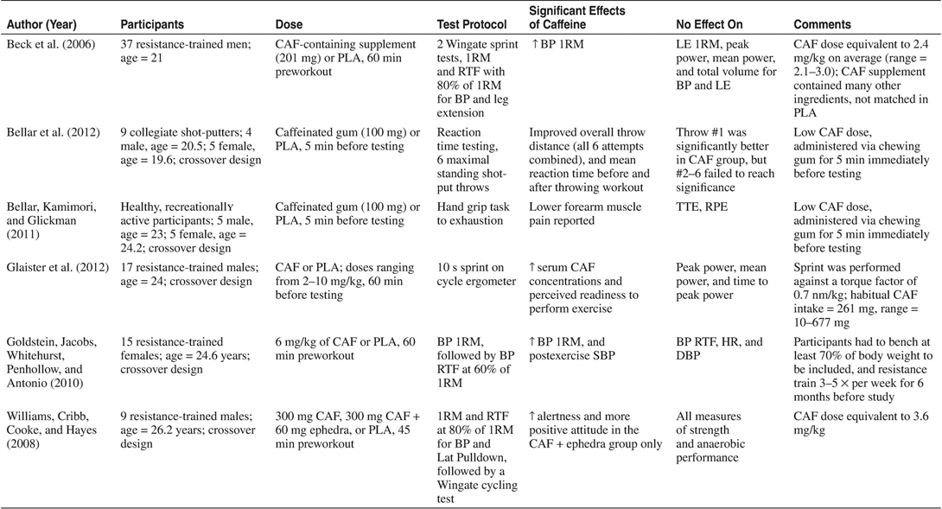

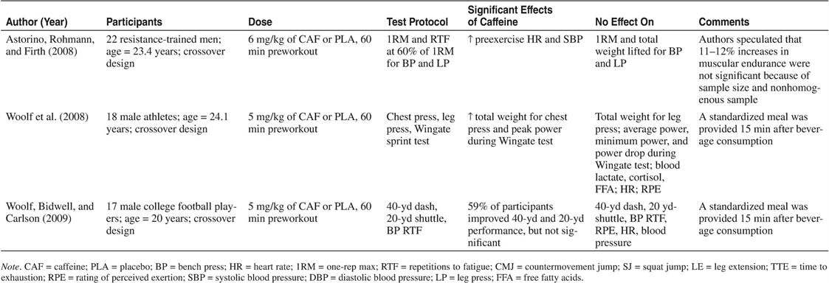

Appendix D
Gene Variants in Gene Doping

